DAA LAB ACTIVITY – 6
Name: RATHISH P P
Roll no: CH.SC.U4CSE24238

AVL tree:
Code:
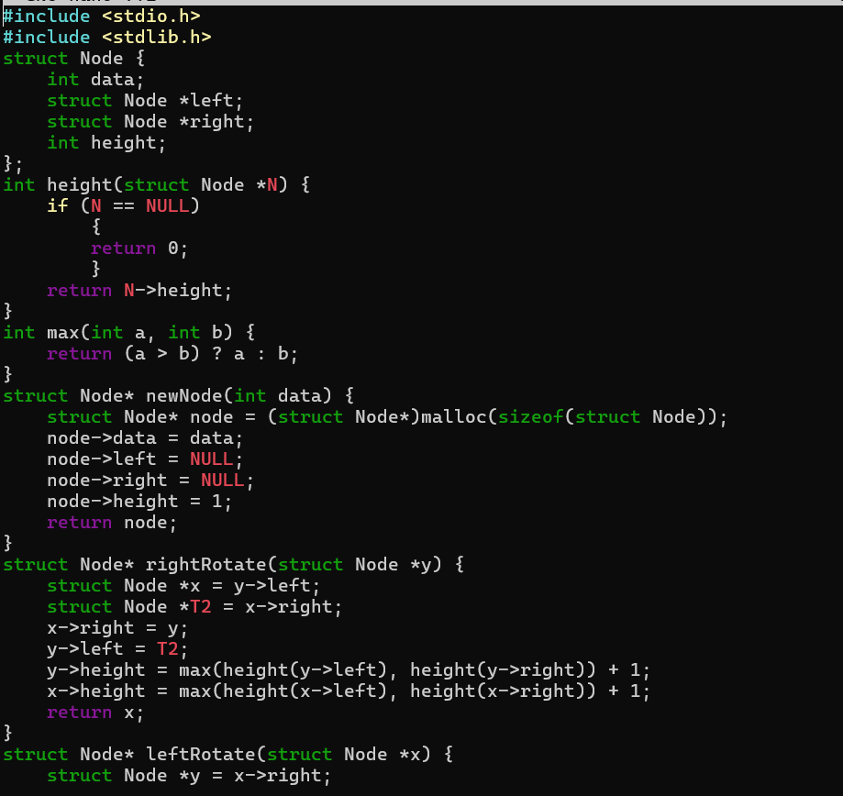
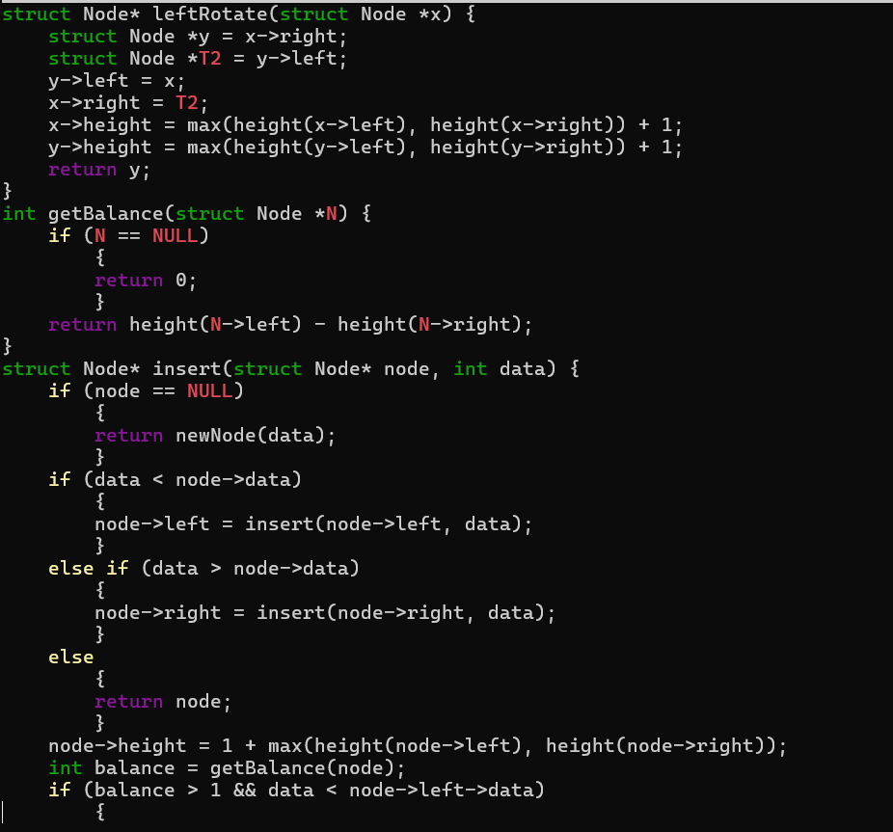
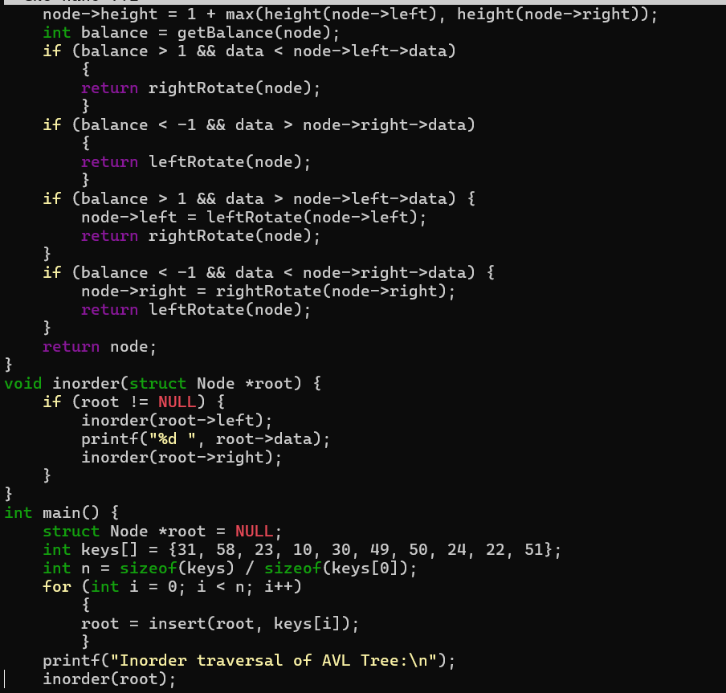
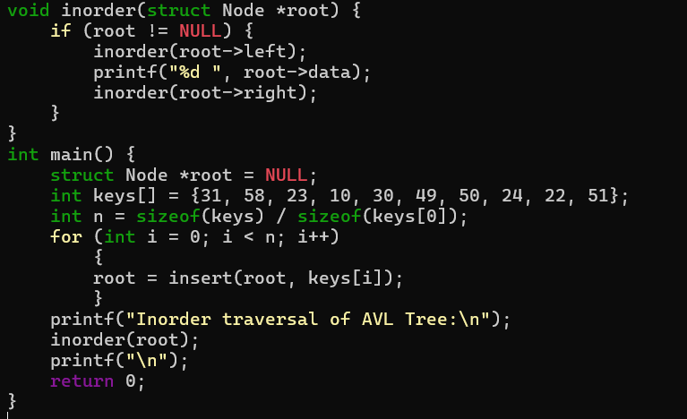
Output:
